Facebook Connect Visual Kit
Version 4.1
Table of Contents
Introduction 2
What is included in the package? 2
Library 2
Demo Website 2
FVK Source Code 2
Frequent problems 3
Settings in the Developer application 4
Create new app 4
Setting Web Site options 4
Migrations 5
Setting application keys 6
Setting Facebook C# SDK 7
Installing FVK in the Visual Studio application 8
Page requirements 8
How to use the controls 9
Login Button 9
Logout Button 10
Stream Publish Popup 11
Stream Publish Friend List 13
Request Dialog 14
Invite Control Classic 15
Invite Control Small 16
Send Status Control 17
Permissions 18
Like Button 19
Send Button 20
Like Box 21
Select Friends Control 22
Comments 23
Bookmark Button 24
Become Fan 26
Share Button 27
Tools 28
Migrations from 2.x to 3.x version 28

Introduction

We want to thank you choosing our solution, the Facebook Connect Visual Kit, since you are reading this manual may we congratulate you on your correct choice that will promise you a fast installation of the FVK library so that you can immediately make use of Facebook's wirde array of tools for your website. If you are reading it for the first time please continue to be guided through all the processes.

Our library was specifically designed for the integration of the visual features of Facebook Connect onto external web sites. Alternatively , you can use Facebook's iFrame applications that can be found on this link here:

http://vatlab.com/facebook-asp-net-libs/facebook-asp-net-user-controls

Initial reported feedback of the libraries first version suggested some common found errors with the installation of some of its components. To avoid this please follow the proposed guidelines. The Frequently Problems Section has solutions that cover roughly 90% of the reported problems.

It is recommended that before attempting an integration by using any control from the library, to read the corresponding section in the guide and compare all the available options.

Our Facebook Page and Twitter page will keep you up-to-date with the latest news on any upgrades.

What is included in the package?

Library
All the essential DLLs and FVK ASCX files are in the Library folder. The library forlder also contatins DLLs needed to work with Facebook C# SDK as underlaying layer for all applications.

Demo Website
Examples of how to use each component is in the demo application. It is already configured for existing Facebook application to work from a local host at port 8181 so you can run it in Visual Studio and test the components based on your various parameters.

FVK Source Code
You can get hold of the FVK library source code if you get the source code license. You can adapt the code and compile it in a new FVKConnect.dll . The FVK Source code also provides you with better debugging options and comprehension of internal workings .

Frequent problems

The solutions to the most common problems are listed here, nevertheless, if it isn’t listed here do no hesitate to email us at info@vatlab.com . Please email us any new issues if they arise.

Some controls are not displayed.

Is the Site URL in the Developer application set right? To view how to configure the Site URL correctly please view the Setting Site URL section.

Some controls do nothing on a mouse click

There are descriptions for each component to allow you to check if the required Java Script is there.

Application does not work on the server

Open your application in Visual Studio and select the „Publish Web Site“ command to publish your application onto the hosting server. A simple copying of the application to the server wont work.

Settings in the Developer application

Regardless of your experience level it is advised to read this section to guareentee correct configuration of your application. It is incorrect settings in the developer application that tends to be the cause for misfunction. This can result in many hours of lost time trying to fix it.

Create new app

Select the application and the screen as shown below appears. Here you enter the Application name and select Agree then Create Application to start the development process.

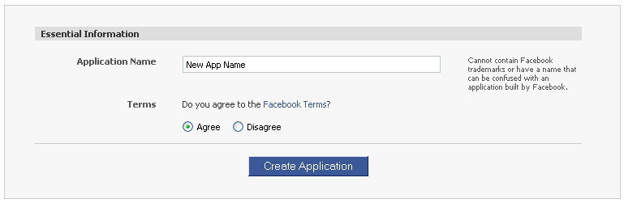

Setting Web Site options

Select the Web Site Section and to set the Site Url. If you work on local host make sure that in Visual Studio its set at the same port. Follow this in Visual Studio to set it up(Project->ProjName Properties->Web->Specific Port). Update your Connect URL after you publish your website on your hosting server, by using the full URL of the hosted website. Changes in your website's location should be updated in the Connect URL, failure in doing so results is misfunctioning of the application.

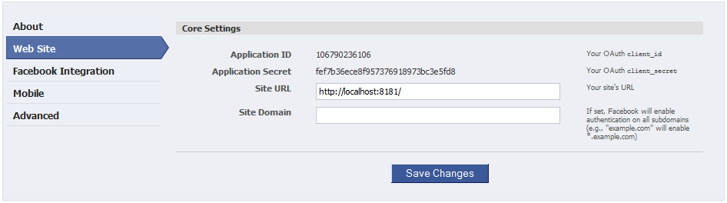

Migrations
Migrations setting depend on the support you receive from the Facebook C# SDK and Facebook Visual Kit. The picture below shows the current supported migrations and how they are to be set for new and existing applications.

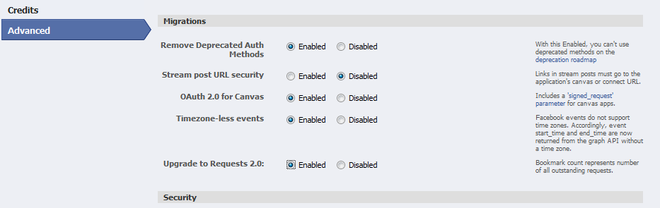

Setting application keys

After creating the application, return back to My Applications and select on the application you just created.

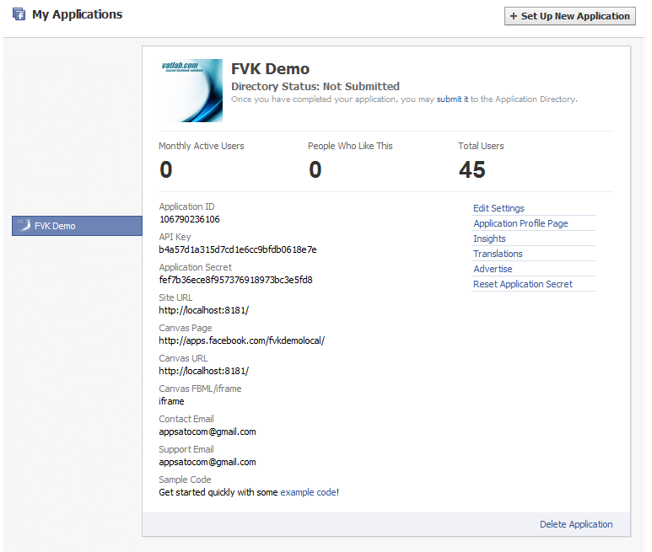

Open the Web.config file in Visual Studio after you created your application and enter these keys into your app settings. The Aplication ID, Secret codes and App name and Site URL should be entered as shown in the fields below:

<appSettings>
<add key="appId" value="<YOUR APPLICATION ID>"/>
<add key="appSecret" value="<YOUR APPLICATION SECRET>"/>
<add key="appName" value="<YOUR APPLICATION NAME>"/>
<add key="appUrl" value="<YOUR SITE URL>"/>
</appSettings>

Setting Facebook C# SDK

Facebook C# SDK is one of the most used .Net library based on Facebook Graph API. Demo website is using this library for getting data from Facebook. To set up the library you have to do following steps in your web.config file:

Add following line inside <configSections>:
<section name="facebookSettings" type="Facebook.FacebookConfigurationSection"/>

Add following lines before or after <appSetting>:
<facebookSettings
appId="="<YOUR APPLICATION ID>"
appSecret="="<YOUR APPLICATION SECRET>"
canvasPage = "<YOUR CANVAS PAGE>"
canvasUrl="<YOUR CANVAS URL>"
siteUrl="<YOUR SITE URL>"
/>

Installing FVK in the Visual Studio application

You need to open the Library folder and within that is the FVK folder, this includes all the files and subfolders, copy it to the root of your source tree inside the project. Visual Studio has to be openend next and then add a reference onto all DLLs contained in the Library forlder.

Note: If you are creating a „ASP.NET Web Application“ project in Visual Studio, please follow this additional step:
Press the Show All Files button in the solution exlorer (), then press the right mouse button on the FVK folder and select Include In Project.

Page requirements

It is essential to include these following lines at the beginning of each page or on the master page (immediately after <%@ Page or <%@ Master tag). The use of master pages is recommended.

<%@ Register TagPrefix="fvk" TagName="initfvk" Src="~/FVK/InitFVK.ascx" %>
<!DOCTYPE html PUBLIC "-//W3C//DTD XHTML 1.0 Strict//EN" "http://www.w3.org/TR/xhtml1/DTD/xhtml1-strict.dtd">
<html xmlns:fb="http://www.facebook.com/2008/fbml" xmlns:og="http://opengraphprotocol.org/schema/">

Include the following line inside the html <head> tag:

<link rel="stylesheet" type="text/css" href="FVK/fvk.css" />

Include the following line immediately after the <body> tag:

<fvk:initfvk ID="initfvk1" runat="server" />

Include the following line immediately after the form tag:

<asp:ScriptManager ID="ScriptManager1" runat="server" />

How to use the controls

Login Button
Facebook Connect enables you to connect to a website by simply pressing the Facebook Connect Login Button control to share the data via the Facebook API. An advantage is also that once you are logged in that all the controls from the library will function without requiring constant logins. The event handler from the control executes some code after the user is successfully logged in.
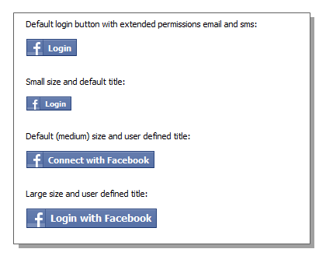

Place the register component tag at the top of the page:

<%@ Register TagPrefix="fvk" TagName="loginbutton" Src="~/FVK/LoginButton.ascx" %>

Place the component tag where you want it to be located inside the page:

<fvk:loginbutton id ="logginButton1" runat="server" />

Event handlers:

OnConnectCalled - protected method that can be implemented inside of the page code which will be called upon when the connection with Facebook is established.

Optional properties:

Size – set the size of the control. Possible values: icon, small, medium, large, xlarge
Title – text inside the login button.
Permissions – comma separated list of extended permissions

Logout Button
Logout Button is used to log out from Facebook. If user is already logged on Facebook, pressing on the Login Button will result in executing of event handler where additional code can be executed.

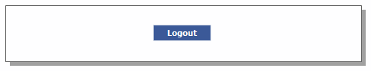

Place the register component tag at the top of the page:

<%@ Register TagPrefix="fvk" TagName="logoutbutton" Src="~/FVK/LogoutButton.ascx" %>

Place the component tag where you want it to be located inside the page:

<fvk:logoutbutton id ="logoutButton1" runat="server" />

Event handlers:

OnLogoutCalled - protected method that can be implemented inside of the page code which will be called upon when the connection with Facebook is closed.

Optional properties:

Title – Button Title
CssClass – CSS class of the button
CssStyle – CSS style of the style

Stream Publish Popup
To publish stories onto the users wall’s, friends wall’s or when as an admin on their Page Wall, the Stream Publish Popup is the function that controls this. This control is a wrapper based on the JavaScript method 'FB.Connect.streamPublish()' . This hides all of the complexities (like JSON conversion, media attachments packaging, etc.) from the user. Whilst configuring within the control that facilitates the stream publish story, it exposes it in pure .NET objects that permits its properties to be customized. It is also possible to check events whether the story has been published and what the user message is.

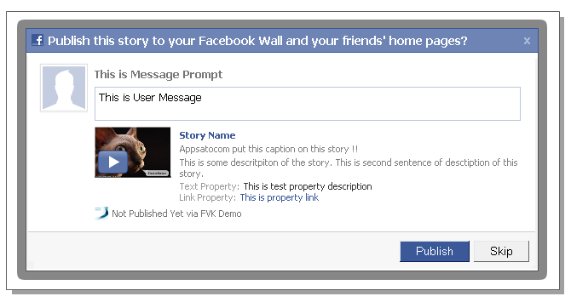

Place the register component tag on top of the page:

<%@ Register TagPrefix="fvk" TagName="streampublishpopup" Src="~/FVK/StreamPublishPopup.ascx" %>

Include JavaScript files in the page header:

<script type="text/javascript" src="FVK/JavaScript/JSON.js"></script>
<script type="text/javascript" src="FVK/JavaScript/StreamPublishPopup.js"></script>

Place the component tag where you want it to be located inside the page:

<fvk:streampublishpopup ID="streampublish1" runat="server" />

Event handlers:

OnPublishCalled – protected method that can be implemented inside of the page code which is called after the popup is shown. Here a code should be placed to inform the user about any missing or incorrect data.

OnConfirmCalled – protected method that can be implemented inside of the page code which is called after a story is published or popup closed without publishing something.

Optional properties:

CommandType – can be set on a link, button or on auto_open which means that the stream publish popup is openend by pressing a link, button or automatically on the page load. Default = button.

CommandTitle – title of command control if a link or button is used for CommandType
Name - story name
Href - story URL
Caption - caption of the story
Description - description of the story
MessagePrompt - message prompt
UserMessage - user message

Media – sets the media object (ImageData, VideoData, FlashData or Mp3Data).

Important: urls of the media object sources cannot be on the localhost. It must point to an address on a public server where Facebook can see it.

TargetId - set to user id to publish on friends' wall
ActorId - set to page id to publish on facebook page wall (only if user is admin of the page)

Important: TargerId and ActorId must not be set at once i.e. if TargetId is set ActorId should be null and vice versa

Stream Publish Friend List
The Stream Publish Friend List control allows you to publish stories on your friends' walls by simply selecting them from the list and clicking the highlighted button. This control is a wrapper based around the Stream Publish Popup control. The control displays a list of friends, which can be defined in the source code, and the 'Publish' button. After selecting a friend and clicking the button, the Stream Publish Popup is shown. Control configuration is nearly identical to the Stream Publish Popup control, with addition of defining a list of friends.

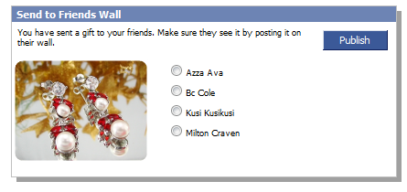

Place the register component tag on top of each page:

<%@ Register TagPrefix="fvk" TagName="streampublishlist" Src="~/FVK/StreamPublishFriendList.ascx" %>

Include JavaScript files in the page header:

<script type="text/javascript" src="FVK/JavaScript/JSON.js"></script>
<script type="text/javascript" src="FVK/JavaScript/StreamPublishPopup.js"></script>

Place the component tag where you want it to be located inside the page:

<fvk:streampublishlist ID="streampublish1" runat="server" />

This control has to be configured the same way as a stream publish popup. However there are some additional properties which have to be set.

BoxText – text inside of the box
MainImageUrl – url of the image inside of the box
Title – title of the box
Friends – list of FriendData objects which have to be in list inside the box
PostBtnTitle – title of post button
HideBtnTitle – title of hide button

Request Dialog
Facebook Send Button is used by users of website to share interesting content with their friends by selecting them from friends list. This will result in sending the message to friends' inbox. There is also an option to send it to the wall of group that user is fan of, or any email address.

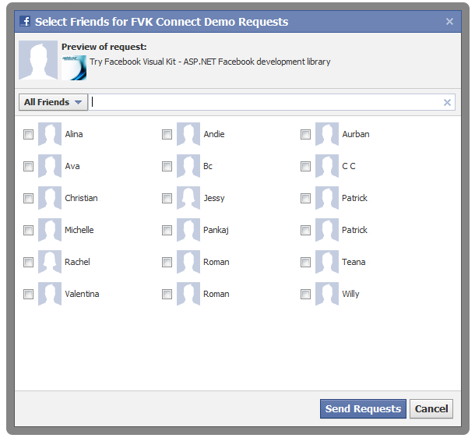

Place the register component tag at the top of the page:

<%@ Register TagPrefix="fvk" TagName="request" Src="~/FVK/RequestDialog.ascx" %>

Place the component tag where you want it to be located inside of the:

<fvk:request ID="request1" runat="server" />

Optional parameters:

Message - Message of request dialog.
Title - Title of request dialog.
FriendId - Id of friend to which request has to be sent. If omited, friend selector is shown.
AdditionalData - Optional data which is sent with request.
CommandType - Can be set on 'link', 'button', or 'auto_open'. This means request dialog is opened by pressing a link, button, or automatically on page load. Default value is 'button'..
CommandTitle - Text of command button or link. If 'auto_open' command type is used, this parameter is ignored. Default value is 'Send Request'.

Invite Control Classic
The Facebook Invite control is used to send invite requests to friends to use a Facebook application or Facebook Connect web site. This control is a wrapper based around FBML tags and is adapted to be used as a pure ASP.NET control.

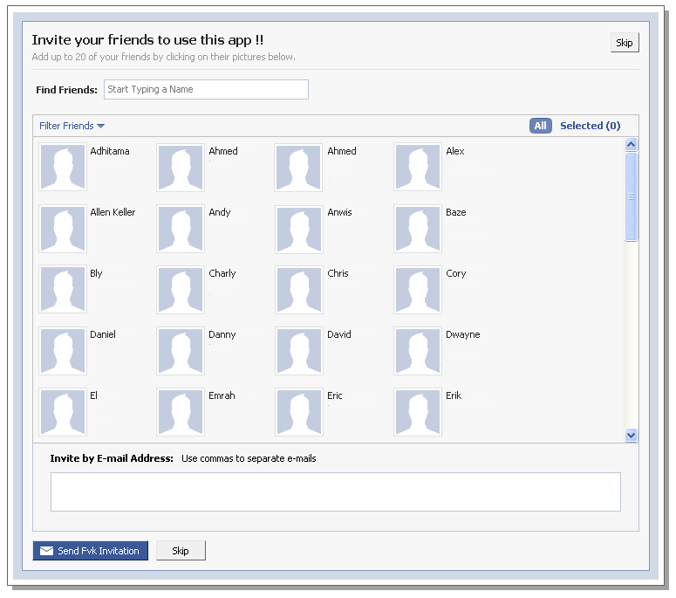

Place the register component tag at the top of the page:

<%@ Register TagPrefix="fvk" TagName="invite" Src="~/FVK/InviteControl.ascx" %>

Place the component tag where you want it to be located inside the page:

<fvk:invite ID="invite1" runat="server" />

Required properties:

MainTitle - main title of control
Content - main description which will appear on invite request

Optional properties:

ActionUrl - URL where app will be redirected after send invitation
AcceptUrl - URL where app will be redirected after invitation accepted
ConfirmButtonTitle - title of confirmation button inside invite request
AppName - Application name displayed on send button and invite request title
ShowBorder – if border has to be shown
EmailInvite – if email control has to be shown
Rows – number of rows
Columns – number of columns

ExcludeFriends - comma separated string of friend IDs which should not to be in invite list
ExcludeFriendsList – List of friend IDs which should not to be in invite list

Invite Control Small
The Facebook Invite Friends Condensed control has the same role as the Invite Control Classic. The difference between them is the layout and size of the control. Also the properties have to be set for the control to function properly.

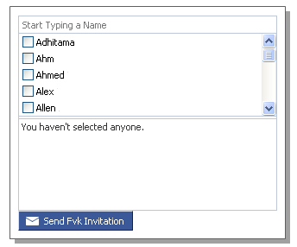

Place the register component tag at the top of the page:

<%@ Register TagPrefix="fvk" TagName="invitesmall" Src="~/FVK/InviteSmallControl.ascx" %>

Place the component tag where you want it to be located inside the page:

<fvk:invitesmall ID="invite1" runat="server" />

Required properties:

Content - Main description which will appear on invite request

Optional properties:

ActionUrl - Url where app will be redirected after send invitation
AcceptUrl - URL where app will be redirected after invitation accepted
ConfirmButtonTitle - Title of confirmation button inside of the invite request
AppName - Application name displayed on send button and invite request title
Width – width of control in pixels
UnselectedRows – number of rows for unselected friends
SelectedRows – number of rows for selected friends
Columns – number of columns
ExcludeFriends - comma separated string of friend IDs which should not to be in invite list
ExcludeFriendsList – List of friend IDs which should not to be in the invite list

Send Status Control

The Send User Status control is used to publish user messages on a user's wall, directly from the Facebook iFrame Application. Before publishing it, the user has to set the permission of post statuses by pressing the link on the control. The control also has an event handler that is called upon successful posting of a user’s message.

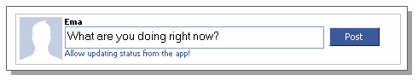

Place the register component tag at the top of the page:

<%@ Register TagPrefix="fvk" TagName="sendstatus" Src="~/FVK/SendUserStatus.ascx" %>

Include JavaScript files in the page header:

<script type="text/javascript" src="FVK/JavaScript/SendStatus.js"></script>

Place the component tag where you want it to be located inside the page:

<fvk:sendstatus ID="sendstatus1" runat="server" />

Event Handlers:

OnSendStatusCalled – protected method that can be implemented inside of the page code which will be called upon when the user status is successfully sent.

Permissions
The Permission control is used to enable users of a Facebook application or Facebook Connect web site to add some permissions , like permissions for sending email, status updates, etc. This control also has event handler which is called if permission is added and allows the developer to add some extra code for this case.

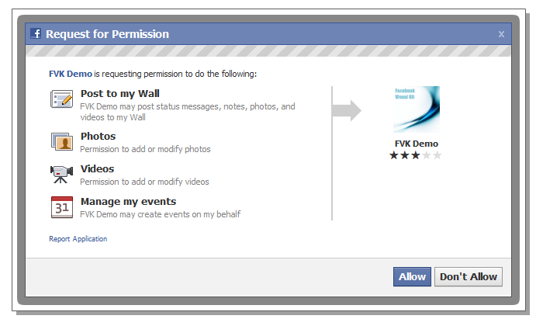

Place the register component tag at the top of the page:

<%@ Register TagPrefix="fvk" TagName="permissions" Src="~/FVK/Permissions.ascx" %>

Place the component tag where you want it to be located inside of the page (example of adding stream publish and video upload permissions):

<fvk:permissions id="permissions1" runat="server" CommandType="button" Text="Add Permissions" PermissionList="publish_stream, video_upload" />

Event Handlers:

OnAddedPermission - protected method that can be implemented inside of the page code which will be called upon when adding of permissions is confirmed by the user.

Optional parameters:

CommandType - can be set on the link, button or auto_open which means permissions popup is openend by pressing a link, button or automatically on page load. Default = link.

Example to add additional email and photo upload permissions in C# code: add these lines on Page_Load method:

permissions1.AddPermission(PermissionEnum.Email);
permissions1.AddPermission(PermissionEnum.PhotoUpload);

List of all available permissions can be found at: http://developers.facebook.com/docs/authentication/permissions

Like Button
Like Button is used that user of website can share interested content with their friends. After user clicks on like button inside you page a story in the user's friends' News Feed appears with link back to your site which increases number of visitors to your site.

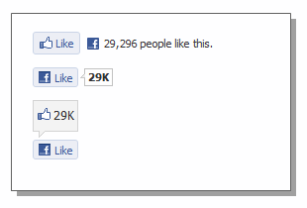
Place the register component tag at the top of the page:

<%@ Register TagPrefix="fvk" TagName="likebutton" Src="~/FVK/LikeButton.ascx" %>

Place the component tag where you want it to be located inside of the:

<fvk:likebutton ID="like1" runat="server" />

Optional parameters:

Url - URL of the like button. If it's not set, current page URL is used
Layout - Layout type. Available values are 'standard', 'button_count', 'box_count'
ShowFaces - Set to true to show profile picture bellow the like button. Default value is true
Width - Width of the like button in pixels. Default value is 450.
Action - Text of the like button. Available values are 'like' and 'recommend'
Font - Font inside the like button. Available values are 'arial', 'lucida grande', 'segoe ui', 'tahoma', 'trebuchet ms' and 'verdana'
SetColorScheme - Color scheme. Available values are 'light' and 'dark'. Deault value is 'light'
Reference - The reference string for tracking referals.

Send Button
Facebook Send Button is used by users of website to share interesting content with their friends by selecting them from friends list. This will result in sending the message to friends' inbox. There is also an option to send it to the wall of group that user is fan of, or any email address.

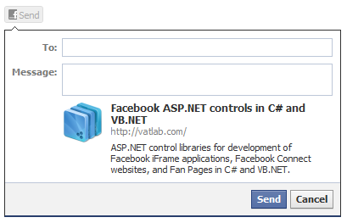

Place the register component tag at the top of the page:

<%@ Register TagPrefix="fvk" TagName="sendbutton" Src="~/FVK/SendButton.ascx" %>

Place the component tag where you want it to be located inside of the:

<fvk:sendbutton ID="send1" runat="server" />

Optional parameters:

Url - URL of the send button. If it's not set, current page URL is used
Font - Font inside the send button. Available values are 'arial', 'lucida grande', 'segoe ui', 'tahoma', 'trebuchet ms' and 'verdana'
ColorScheme - Color scheme. Available values are 'light' and 'dark'. Deault value is 'light'
Reference - The reference string for tracking referals.

Like Box
This control is used to allow users of the web site to become fan of the Facebook page, see messages from the page wall and people who are fans of the page.

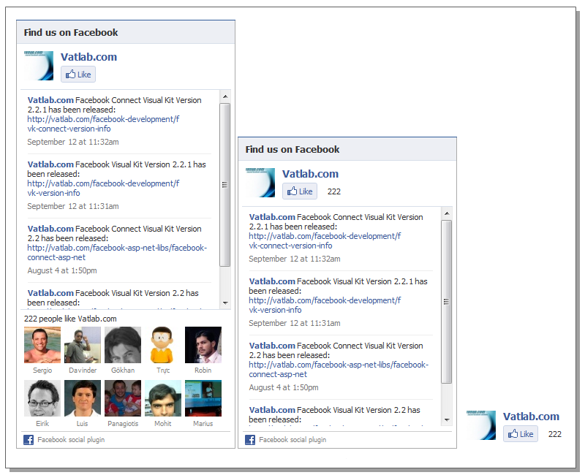

Place the register component tag at the top of the page:

<%@ Register TagPrefix="fvk" TagName="likebox" Src="~/FVK/LikeBox.ascx" %>

Place the component tag where you want it to be located inside of the:

<fvk:likebox ID="likebox1" runat="server" />

Optional parameters:

PageId - Facebook Page ID
Width - Width of the like box in pixels. Default value is 292
FansCount - Number of fans to display. Default value is 10
ShowStream - Set to true to show the massages from the Page Wall
ShowHeader - Set to true to show the header

Select Friends Control
This control is used to select Facebook friends as easily as possible. The control has two types of filtering methods and three types of selection methods. There is also possibility to change the number of rows and columns.

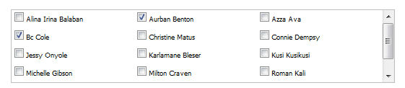

Place the register component tag at the top of the page:

<%@ Register TagPrefix="fvk" TagName="selectfriends" Src="~/FVK/SelectFriends.ascx" %>

Place the component tag where you want it to be located inside the page:

<fvk:selectfriends id="sfriends1" runat="server" />

Event handlers:

OnSelectionChanged - method that can be implemented inside of the page code which will be called upon when a selection of friends is changed.

Required properties:

Rows - number of rows
Columns - number of columns

Methods:

SelectAll(void) – select all users displayed in list
UnselectAll(void) – unselect all users
SelectAppUsers(void) – select all users displayed in list who are application users

FilterByNameStartsWith(string) – filter list to display just those friends who have a name which starts with input parameter
FilterByNameContains(string) – filter list to display just those friends who have a name which contains input parameter

Comments
The Comment box control is used to permit Facebook Connect web site users to make comments about a web site or some article on the Connect web site. There is a possibility to distinguish between comment boxes inside the same web site by setting unique ID for each comment box.
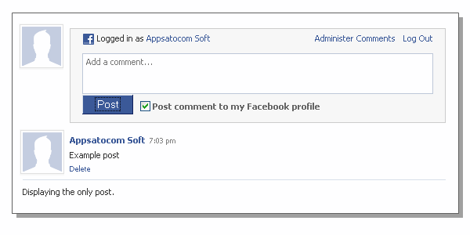

Place the register component tag at the top of the page:

<%@ Register TagPrefix="fvk" TagName="comments" Src="~/FVK/Comments.ascx" %>

Place the component tag where you want it to be located inside the page:

<fvk:comments ID="comments1" runat="server" />

Optional properties:

Xid – unique id. Should be set if there are more comment boxes for the same web site.
PostsNum – The max number of posts to display. Default is 10.
Width – width of the control. Default is 550.
CssUrl - URL of custom CSS style of the control
Title – title of the feed story published when comment is made. Default is the title of page.
Url – the URL of a page where the comment is made.
IsSimple – a rounded box does not appear around each post on a site. Default is false.
IsReverse – if true comments are shown in reverse order. Default is false.

Bookmark Button
The Bookmark button is used to permit an easy way of bookmarking a Facebook Connect website or Facebook application inside the Facebook environment. If a web site or an facebook application is already bookmarked, or has not a connection to Facebook established, the button is not shown.

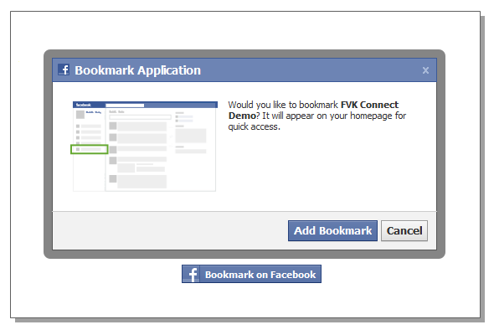

Place the register component tag at the top of the page:

<%@ Register TagPrefix="fvk" TagName="bookmark" Src="~/FVK/BookmarkButton.ascx" %>

Place the component tag where you want it to be located inside the page:

<fvk:bookmark ID="bookmark1" runat="server" />

Event handlers:

OnAddedBookmark - method that can be implemented inside of the page code which will be called upon when a application is bookmarked

Become Fan
The Become Fan Box control is used to allow users to become fans of a Facebook application, a Facebook Connect web site or a Facebook page. The control can be used in two forms: permitting a user to become a fan simply by clicking a button inside the control (left picture) and additionally to display number of fans and stories published on the application wall, web site or Facebook page.

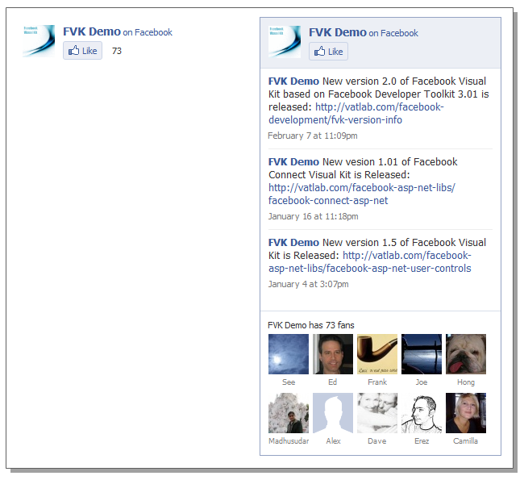

Place the register component tag at the top of the page:

<%@ Register TagPrefix="fvk" TagName="fan" Src="~/FVK/BecomeFan.ascx" %>

Place the component tag where you want it to be located inside the page:

<fvk:fan id="fan1" runat="server" />

Optional properties:

Width – width of the control, default is 300
ShowStream – set to true to show messages from app wall, default it false
ConnectionsCount – set number of fans to display, default is 0
CssUrl – URL of custom CSS style of the control

Share Button
The Facebook Share Button is used for sharing interesting links from web pages, Facebook apps, Facebook Connect web sites or Facebook Pages. To share these links on Facebook you click on the share button which results in a new story being published on a user’s wall. The link is defined within the share button. There are 5 shapes of this button, displayed on the picture below.

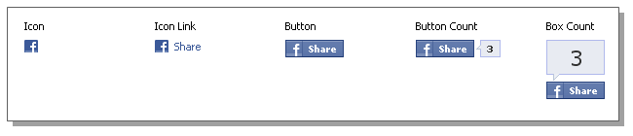

Place the register component tag at the top of the page:

<%@ Register TagPrefix="fvk" TagName="sharebutton" Src="~/FVK/ShareButton.ascx" %>

Place the component tag where you want it to be located inside the page:

<fvk:sharebutton id="sharebutton1" runat="server" />

Optional properties:

Type – Shape type of share button (icon, icon_link, button, button_count, box_count), default = icon_link
Title – title of share button
Url – url of content page which have to be share if it is not on current page

Tools

Conversions class contains 4 methods to convert a list of friend data to list of ids as longs, list of name strings, comma separated string representation of list ids and comma separated string representation of list of names.

Migrations from 2.x to 3.x version
Facebook Visual Kit 3.x has completely changed implementation of almost all components. Interfaces of all components are kept almost the same. However there are some stuff which are not anymore supported in Graph API which are also excluded from components. All components are now totally independent from any underplaying .NET SDK, they are based only on Graph API JavaScript SDK and XFBML. Here are the steps to adapt your existing applications based on 2.x version on 3.x.

- Replaces all occurrences of EnableXFBML including register tag and control tag with InitFVK control.
- Delete all occurrences of JavaScript include with FeatureLoader.php.js text
- Delete all SetApi(…) methods from code since FVK is now independent of the .NET SDK
- Set additional values in web.config file as it is described in ‘set application keys’ section.

